Modelsim

- Goal – Teach students how to use Modelsim.
- Learning outcome - by the end of this class the students should be able to do simulation and timing diagram analyzes on Modelsim.

This is the ModelSim simulator screen called from the Quartus to simulate your circuit’s behavior.
On the left tree of items choose the item “work” expand it and find there your project.

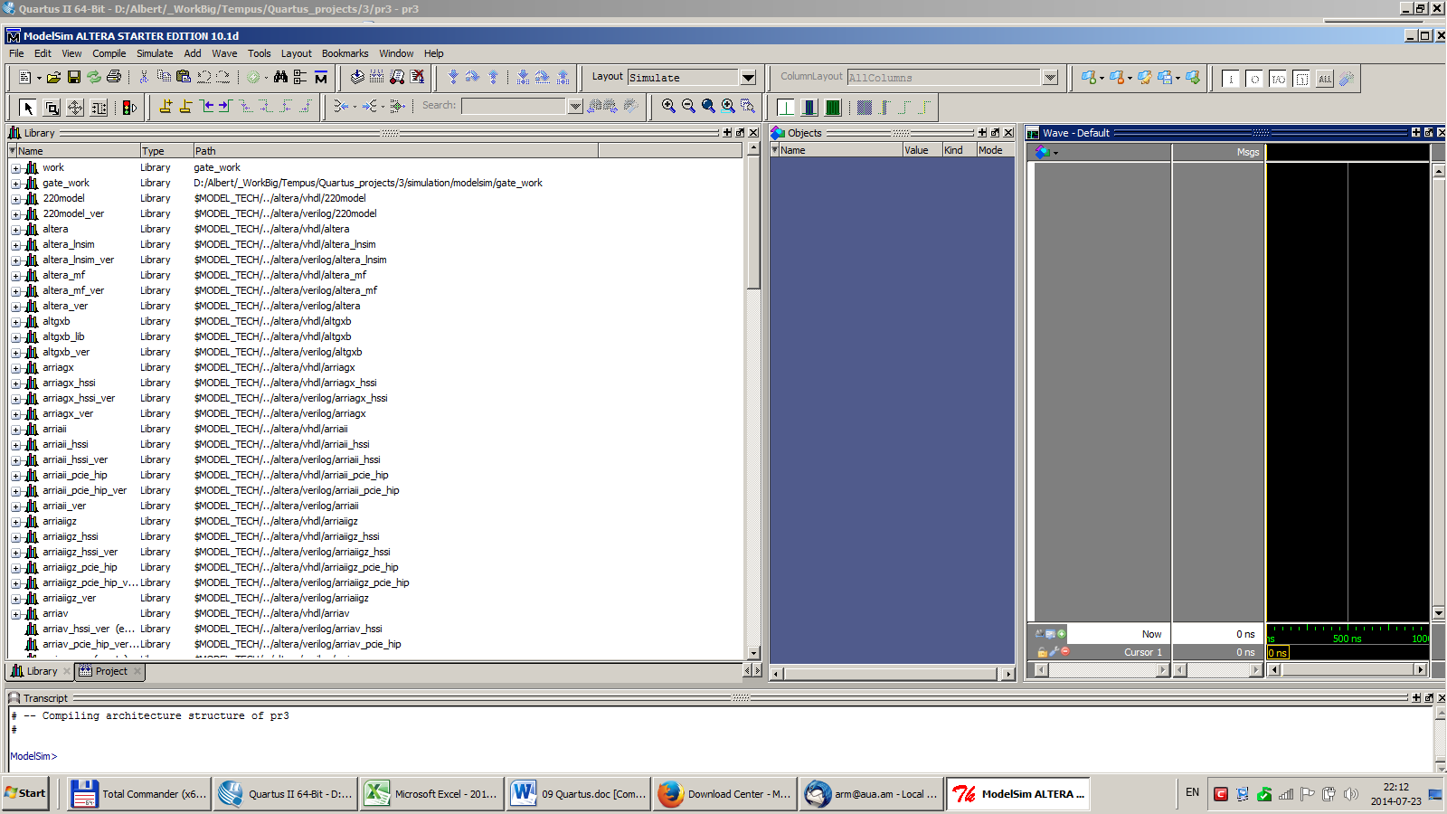

Double click on your project. Expand your project also and choose the item “structure”. You’ll see the objects in the 2nd panel of your simulator.

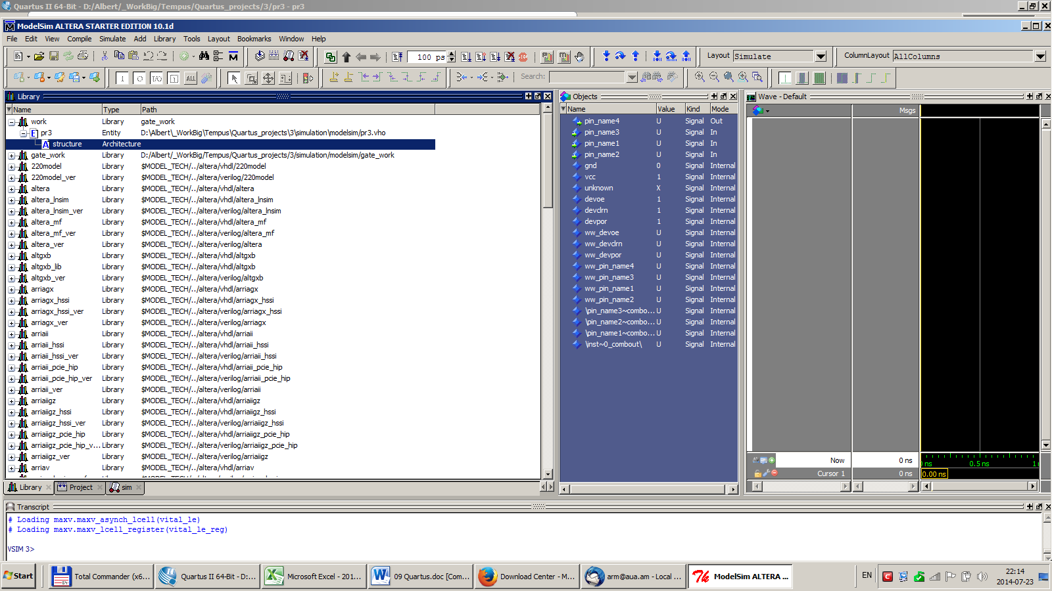

You’ll see the objects in the 2nd panel of your simulator. Your simulation result will be shown on the rightmost coulumn (black window). To see the simulation result you should assign some signals to the inputs and choose outputs where you want to observe the signals.

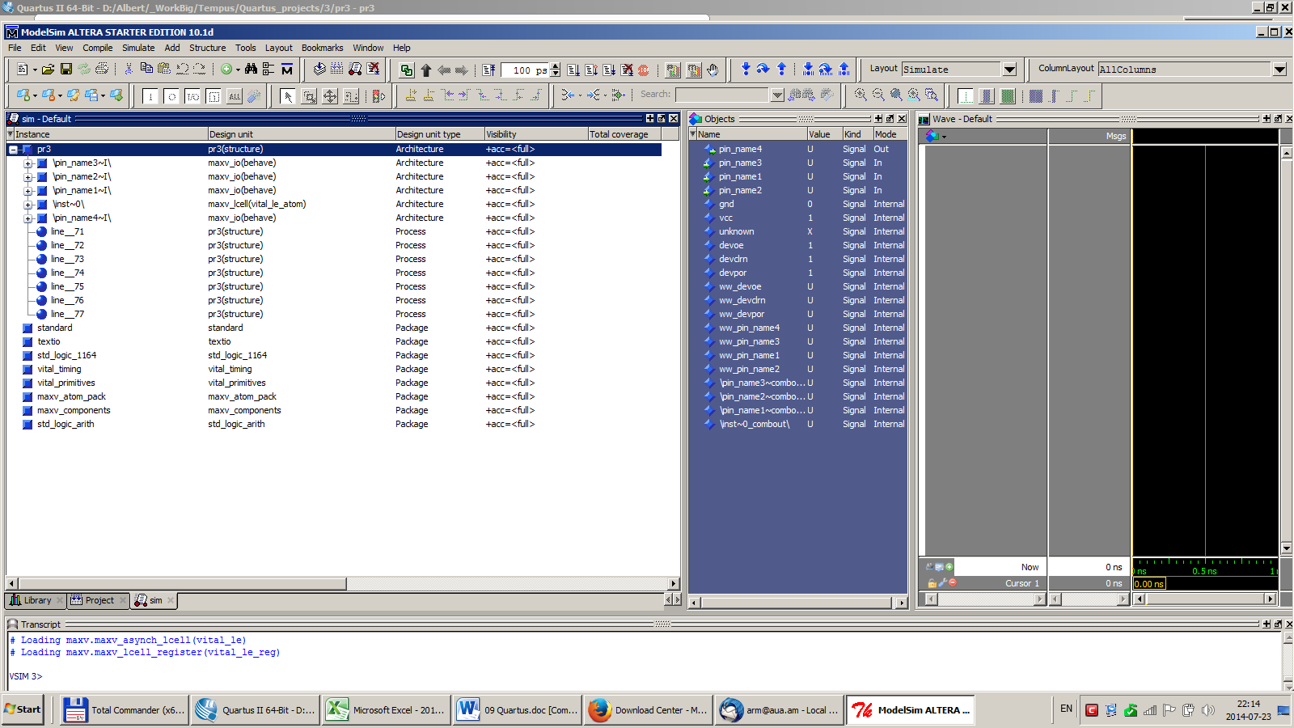

The selection of inputs and outputs to participate in the simulation is done by drugging/dropping the appropriate pins from the 2nd coulumn (blue) to the 3rd column (grey).

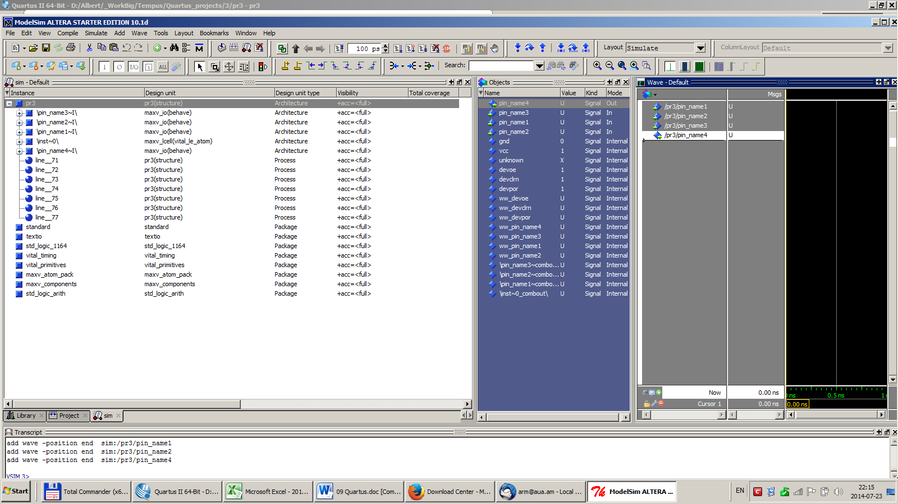

After populating the simulation grey window with the appropriate inputs and outputs you should assign some signals to the inputs. You do this by right clicking on the corresponding input and selecting values or signals for them. On below picture to the input1 is assigned a clock.

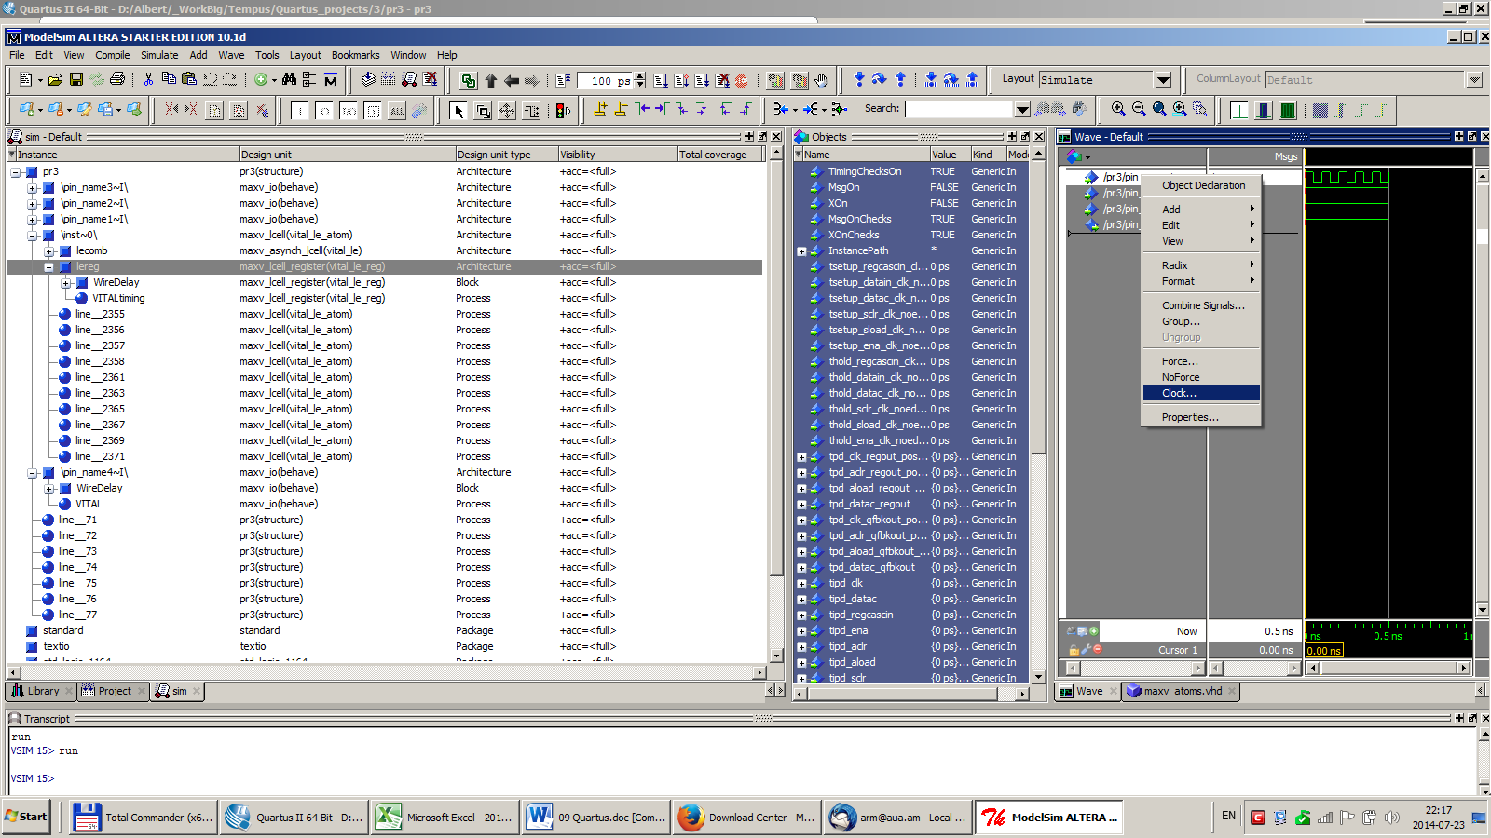

You can choose the clock parameters on the dialog opened after seleting the clock line in the drop down menu after right click. After pressing OK on the dialog the signal is assigned to the input.

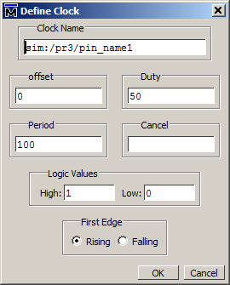

You can assign logical level values to the inputs in the same way as you assign the clock signal to the input1. Right click on the input you want to assign a level signal and select “Force…”

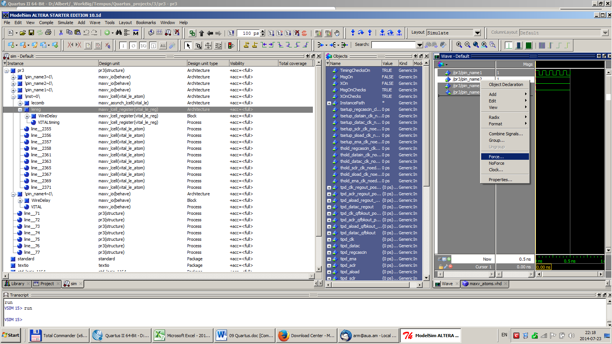

On this dialog you can assign the level 1 or 0 for your input signal.

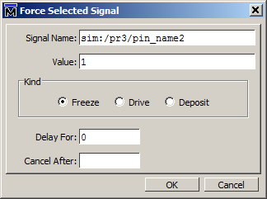

When you have done all the inputs assignment then you can start the simulation and observe the inputs and outputs on the rightmost black window of waves.

Press F9 or Run button to see the waves.

